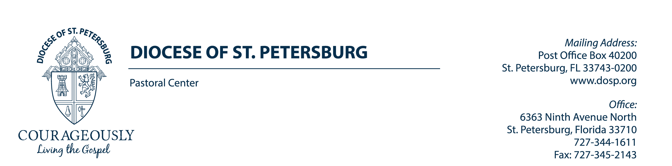
Lay Pastoral Ministry Institute
Dale Brown, Director
(727) 344-1611, ext. 5458
Ana Jahuey, Administrative Assistant
(727) 344-1611, ext. 5471
“God’s People Doing God’s Work”

The Lay Pastoral Ministry Institute is asking for your support in promoting our program. Please include one of the following bulletin announcements in your Parish Bulletin, Mass Announcements and Parish Website.
Thank you very much for your support of the Lay Pastoral Ministry Institute. You can find the bulletin announcements on our webpage where you can copy them to use. You can also scan the QR codes used below to get to the webpage.

“All of us need to grow in Christ.” (Pope Francis, Joy of the Gospel, 160)

ANNOUNCEMENTS for PARISH bulletin, MASS ANNOUNCEMENTS and PARISH WEBSITE

My Lord God, I have no idea where I am going. I do not see the road ahead of me. I cannot know for certain where it will end. Nor do I really know myself, and the fact that I think that I am following your will does not mean that I am actually doing so.
But I believe that the desire to please you does in fact please you. And I hope I have that desire in all that I am doing. I hope that I will never do anything apart from that desire. And I know that if I do this you will lead me by the right road though I may know nothing about it. (Thomas Merton)

“Lay people “participate, in their own way, in the priestly, prophetic, and royal function of Christ himself. The Council, therefore, does not look at lay people as if they were “second class” members, at the service of the hierarchy and only executors of orders from on high, but as disciples of Christ who, by force of their baptism and their nature inserted “in the world,” are called to animate every space,
every activity, every human relation according to the spirit of the Gospel.” - Pope Francis

An Invitation from the Office of the Lay Pastoral Ministry Institute (LPMI)

So often, people ask how they might grow in their faith. In response to this searching, the Lay Pastoral Ministry Institute was initiated in 1998. The LPMI provides education and formation for laity in the Catholic faith. The program is designed to enhance personal faith and develop intellectual aptitude to enrich personal ministry. It is a four-year program: an informal year of discernment and three years of formal academic training and spiritual growth. Upon completion of the program, participants are formally “commissioned” by the Bishop.

The initial segment of the program, the Year of Discernment, consists of eight Saturday sessions from 9:30 am to 3:00 pm. The classes meet at Christ the King Parish, located at 821 S. Dale Mabry Hwy, Tampa. Classes begin on September 7, 2024 and continue once monthly through April 2025. For anyone interested in attending the LPMI Year of Discernment, the registration form and program information can be found on the LPMI web site at: https://www.dosp.org/lpmi/year-of-discernment/ or call the LPMI office at (727) 344-1611. Registrations are due in the LPMI office no later than September 5, 2024.

An Invitation from the Office of the Lay Pastoral Ministry Institute

Ask yourself: Could God be calling me to be a Lay Ecclesial Minister in His Church? Our Diocese is blessed with many lay women and men who love God and wish to serve Him. In response, our diocese initiated the Lay Pastoral Ministry Institute to equip Catholic to “be more” by forming them Spiritually, Intellectually, Theologically and Pastorally to serve as Lay Ecclesial Ministers. We are grateful for this rare educational opportunity, which is not available in all dioceses. To date, over 400 men and women have been commissioned by the Bishop to share their gifts and talents in our diocese. New classes begin September 7, 2024. For anyone interested in attending the LPMI Year of Discernment, the registration form and program information can be found on the LPMI web site at: http://dosp.org/lpmi/ or call the LPMI office at (727) 344-1611.

An Invitation from the Office of the Lay Pastoral Ministry Institute
Saint Pope John XXIII once said, “Consult not your fears but your hopes and your dreams. Think not about your frustrations, but about your unfulfilled potential. Concern yourself not with what you tried and failed in, but with what it is still possible for you to do.” Ask yourself: Would I better serve my ministry by attending a program designed to prepare me for my responsibilities?

The initial segment of the LPMI program, the Year of Discernment, consists of eight Saturday sessions from 9:30 am to 3:00 pm. The classes meet at Christ the King Parish, located at 821 S. Dale Mabry Hwy, Tampa. Classes begin on September 7, 2024 and continue once monthly through April 2024. Classes offered include Lay Spirituality, Ministry, Who Am I as Leader? and Discernment. For anyone interested in attending the LPMI Year of Discernment, the registration form and program information can be found on the LPMI web site at: http://dosp.org/lpmi/ Or call the LPMI office at (727) 344-1611. Registrations are due in the LPMI office no later than September 5, 2024.

An Invitation from the Office of the Lay Pastoral Ministry Institute

An Invitation from the Office of the Lay Pastoral Ministry Institute
Pray & Reflect: Is God Calling You to Serve as a Lay Ecclesial Minister in His Church?
“The Holy Spirit, whom the Father will send in my name, will teach you everything and remind you of all that I told you. Peace I leave with you; my peace I give to you.” (John 14:26-27) - “Laypeople are called to help animate the world with the spirit of Christ.” (Vat. II: AA, Art. 2) The LPMI Year of Discernment provides a theological overview of the Church and Christ’s ministry and can offer you a greater sense of your place as laity in the Church. Ask yourself: Am I willing to step out of my “comfort-zone” to enhance my spirituality and grow in my faith formation? - We seek to develop understanding and appreciation of the Catholic faith. Through your participation, you will begin to see more clearly the gifts and strengths which you can bring to ministry. Anyone interested in attending the LPMI Year of Discernment monthly sessions, can find more details on the LPMI web site at http://dosp.org/lpmi/ . Or, you may contact our staff at the Pastoral Center by phone (727) 344-1611 or send an email to: LPMISEPI@DOSP.ORG (Scan the QR code to visit the LPMI website!)

+ + +

An Invitation from the Office of the Lay Pastoral Ministry Institute

Church ministry requires an authentic call and also genuine competence. This call comes from the Lord and is recognized by the Church but must also be guided by competence.

Effective lay ecclesial ministers need more than a heart for ministry; they also need personal and spiritual maturity, knowledge of theology and other disciplines and pastoral skill. Lay ministers need and deserve a formation program with high standards, effective methods and comprehensive goals. This is what we, here in the Diocese, work hard to offer to you.

Ask yourself: Do I feel in my core that God is calling me to follow Him more closely in a ministry leadership role to spread the gospel of Jesus Christ?
A new class begins on September 7, 2024. Anyone interested in attending the LPMI Year of Discernment monthly sessions, can find more details on the LPMI web site at http://dosp.org/lpmi/. Or, you may contact the LPMI office at the Pastoral Center by phone (727) 344-1611 or send an email to: LPMISEPI@DOSP.ORG (Scan the QR code to visit the LPMI website!)

